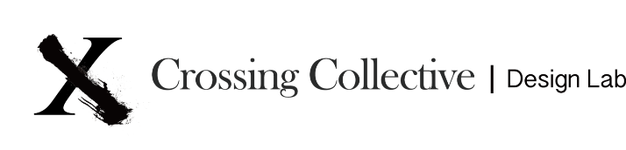
559 West 23rd Street, New York, NY 10011 212.359.4333
www.crossing-collective.com
Press Contact: Wesley Sin wesley@crossingart.com

Six Impossible Things Before Breakfast
Opening Reception: Thursday, May 3rd, 2018 6-9PM

Crossing Collective is pleased to present ‘Six Impossible Things Before Breakfast’, a group exhibition curated by Beth Fiore including works from Alex Ebstein, Susan Klein, Adam Eddy and Allison Remius, on view from May 3rd to July 7th, 2018.

"There's no use trying," Alice said: “One can't believe impossible things."
"I daresay you haven't had much practice," said the Queen. "When I was your age, I always did it for half-an-hour a day. Why, sometimes I've believed as many as six impossible things before breakfast."

This exhibition takes its title from an excerpt of Lewis Carroll’s famed Through the Looking Glass, in which a young Alice falls through a mirror and finds herself too large and then too small in a world that contradicts usual paths of logic. Like the world beyond the rabbit hole, quantum theory frequently disobeys the theories of classical physics, an idea that fascinated and perplexed Carroll, as evident in much of his writing. Even the presence of the Cheshire Cat as Alice’s enigmatic antagonist is almost certainly a nod to the notorious Schrodinger’s Cat experiment, in which a cat was theoretically proven to be both dead and alive simultaneously.

* * *

The artists included in this show, like Carroll, are exploring the often illogical world of higher relationships between contradicting states and things. Using a wide range of tropes from late pop art to post-minimalism, these works rely on a vocabulary outside of volumetric terms of formal analysis, shifting to space with no fixed boundaries or center.

Alex Ebstein’s work utilizes a visual index of organic shapes, which may be literal or metaphorical extensions of the body’s simultaneous presence and absence. Despite a decidedly hand-made approach, her unorthodox media and obvious graphic design tropes are cheeky allusions to mass-produced industrial goods, reminiscent of Warholian humor.

Susan Klein makes work about time. As a printmaker, issues of immediacy and repetition are confronted head on through her medium, while her subject matter operates on a more extended, rational timeline; the dense geometric landscapes of deconstructed obstacle courses are indicative of some vague narrative. Many of these works employ a 4-dimensional quality, always a sense that we are witnessing a kinetic event as it occurs in relation to time passing.

Adam Eddy’s paintings use the shape of his supports as a part of the painted composition, combining structure and content to create work that is simultaneously image and object. The result is a kinesthetic relationship between viewer and art, dissolving the boundary between one and the other.

Allison Reimus is another artist interested in the liminal space between object and idea. Alluding to the everyday non-art objects venerated by Claes Oldenberg, she is exploring the ways in which decoration can be art, particularly in the case of traditionally non-art materials. A groundwork of simple geometry in 2-dimensional space creates a level playing field for a complex hierarchy of textures and surfaces to extend off of her supports into the 3rd dimension.

Finally, works by Andy Warhol, John Chamberlain, Richard Tuttle, Richard Artshcwager and Tom Wesselmann will be included. These historical works are not meant to provide context in the otherwise contemporary exhibition, but to be objects in a space, to utilize history as a medium rather than a curatorial framework. In a nod to the quantum theory referenced in this show, these ‘objects’ are included to metaphorically challenge accepted notions of physics, suggesting that art history takes up space in the same way that time does. In the world through the looking glass, there is no history, no context, only math.

